Monthly Recap:

**DICKENS COUTY 4-H NEWSLETTER**



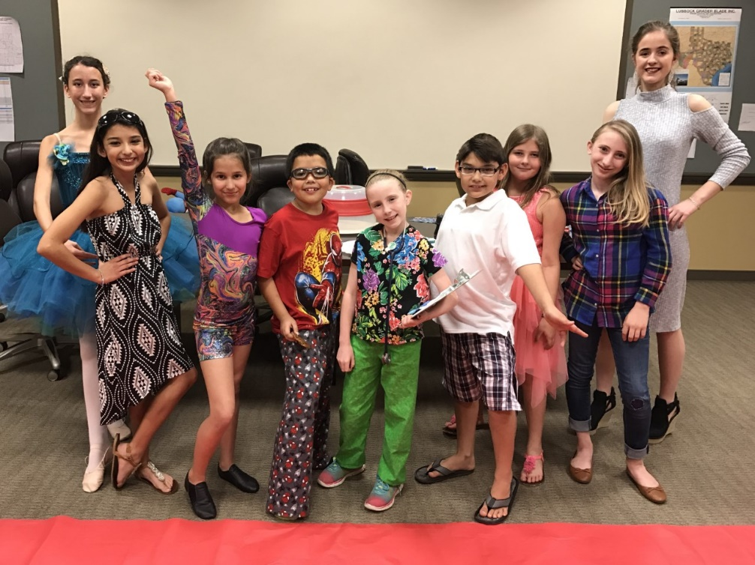Started out the Month with the County Fashion Show and it was a success. We had a great turn out and great feedback from our Judges. The judge was Sherly Long and she did an excellent job with giving our 4-Her’s feedback so they can have better interviews at the District contest. The contestants included Audrey Baugh, Melania Ramirez, Bailey Baugh, Jet Ramirez, Lyndee Foster, Diezel Ramirez, Mackenzie Gardner, Jaydee Foster, and Shaylee Boger. All the contestants will be moving on to the District Contest in Graham, TX on April 1st.

Next, we had the Work Day for the Dickens County 4-H Arena. A lot of work was done in a short period. From cleaning out the pens to fixing up the announcer stand, we have made the facility ready for the Play- Day season this year.

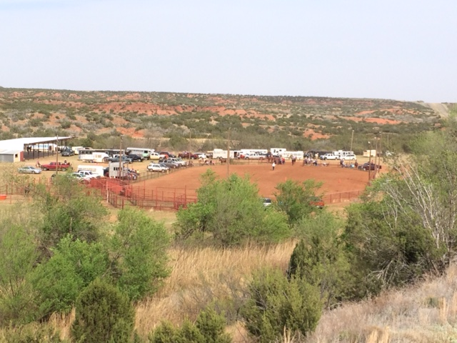The first Playday to start off the Season was a great success. The wind gave us a hard time but even so we had over 60 contestants making it one of the best turn outs for our Playdays. We had everyone gain more experience and everybody had a good time. The next Playday will be held on April 23rd with Books opening at 1:30 and the event starting at 2:00.

**DICKENS COUTY 4-H NEWSLETTER**



Future events:

* April 1st -April 15th – Horse Validation - $10
* May 20th- District Shotgun
* May 21st- Play Day
* June 6-9th Texas 4-H Round-Up
* June 11th – Play Day Awards
* June 21-23 District Horse Show – Vernon
* June 27-29th Teen Leader Lab
* July 16-19th Prime Time Camp I (5th- 8th grade)- Brownwood
* July 19-22nd Prime Time Camp II (2nd- 5th grade)- Brownwood
* July 22-29th State Horse Show- Abilene