Monthly Recap:

**DICKENS COUTY 4-H NEWSLETTER**



The District Fashion Show was held in Graham, TX at North Central College on April 1, 2017. It was a very successful day for Dickens County 4-H and everyone gained some valuable experience. The participants were Shaylee Boger participated in Special Interest (1st) and Fashions under $25(2nd), Melania Ramirez participated in Everyday Living (3rd) and won the Modeling Portion for the Intermediate Division, Jaydee Foster participated in Fashions under $25 (3rd), Audrey Baugh participated in Special Interest (3rd), Diezel Ramirez participated in Refashion construction, Lyndee Foster participated in Costume (1st), Jet Ramirez participated in Construction Pull on shorts division (4th), and Bailey Baugh participated in Special Interest (2nd). Additionally, we had participants in the Storyboard competition with Shaylee Boger placing 1st in her division and Melania Ramirez placed 3rd in her Division. We would like to thank the North Central College for hosting the event as well as all the Adult Leaders that helped with the event.

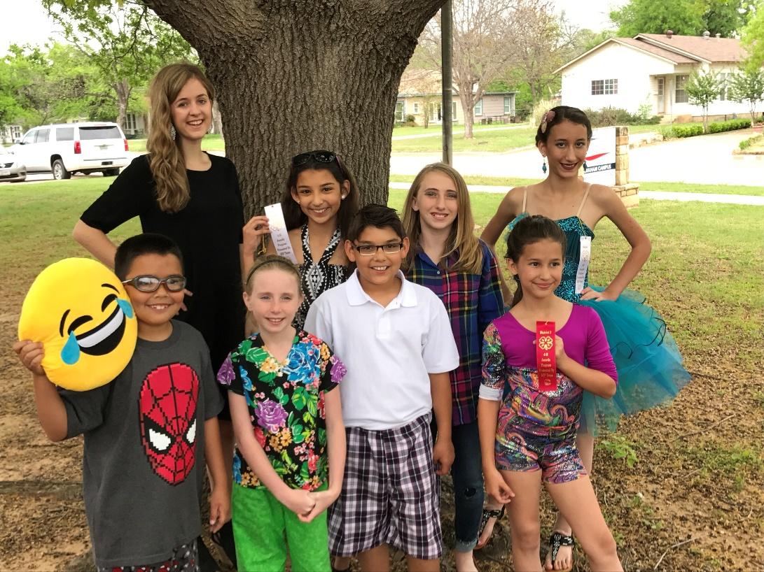

Horse Judging:

**DICKENS COUTY 4-H NEWSLETTER**



Horse Judging was held in Vernon, TX on April 10th. There was a great turn out for the District and the County and was overall a great competition. Even with this stiff competition we still had success. Mackenzi Gardner placed 4th overall, and Lyndee Foster placed in the top 20 in the Jr. Division, Bucki Smith and Gunnir Bateman place in the Top 25 in the Intermediate Division, Jaydee Foster also participated in the Intermediate Division, and Belle Smith placed 7th and Jadyn Duggan Placed 10th in the Sr. Division. Overall a very good day for Dickens County 4-H.

Horse Quiz Bowl:

Some Stiff competition came to the Horse Quiz Bowl this year. Held April 10th in Vernon Horse Quiz Bowl offered an opportunity to learn more about horses and then test that knowledge. Participants were, Mackenzi Gardner, Jaydee Foster, Lyndee Foster, Kollier Miller, Gunnir Bateman, and Bucki Smith. Although we did not come home with a banner we did eat Pizza Hut and Braum’s so who were the real winners.

Playday:

The 2nd Playday to start off the Season was a remarkable success. We had a very good turn out this time around for the Playday. We had everyone gain more experience and everybody had an enjoyable time. The next Playday will be held on May 21st with Books opening at 1:30 and the event starting at 2:00.

**DICKENS COUTY 4-H NEWSLETTER**



Adopt- A- Highway:

Sunday April 9th was the Adopt-A-Highway clean-up day. We had a great turn out and picked up a significant amount of trash that was on Loop 121. Participants are as followed: Llano Bateman, Gunnir Bateman, Belle Smith, Mackenzi Gardner, Lyndee Foster, Jaydee Foster, Bucki Smith, Melania Ramirez, Paisley Smith, Alyssa Fulmer, Noah Tanner, Alyssa Ellis, Courtney Taylor, and Rilee Foster. It was overall a very good Community Service Project and a good thing for the community.

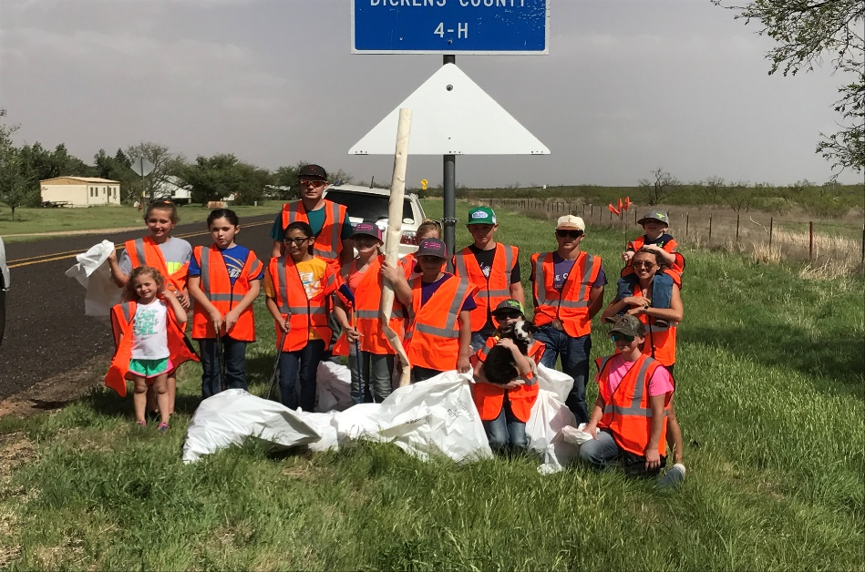

Livestock Judging:

**DICKENS COUTY 4-H NEWSLETTER**



An awesome day for the Dickens County Livestock Judging team. Everyone that participated did an excellent job. Participants are as followed, Jaydee Foster who placed in the top 25, and Mackenzi Gardner who placed 4th overall in the Jr Division, Gavin Arnold, Kollier Miller placed in the top 25 , and Gunnir Bateman placed 3rd overall and 4th overall in Reasons in the Intermediate Division and the Team placed 6th overall, and Jayden Duggan participated in the Sr. Division.

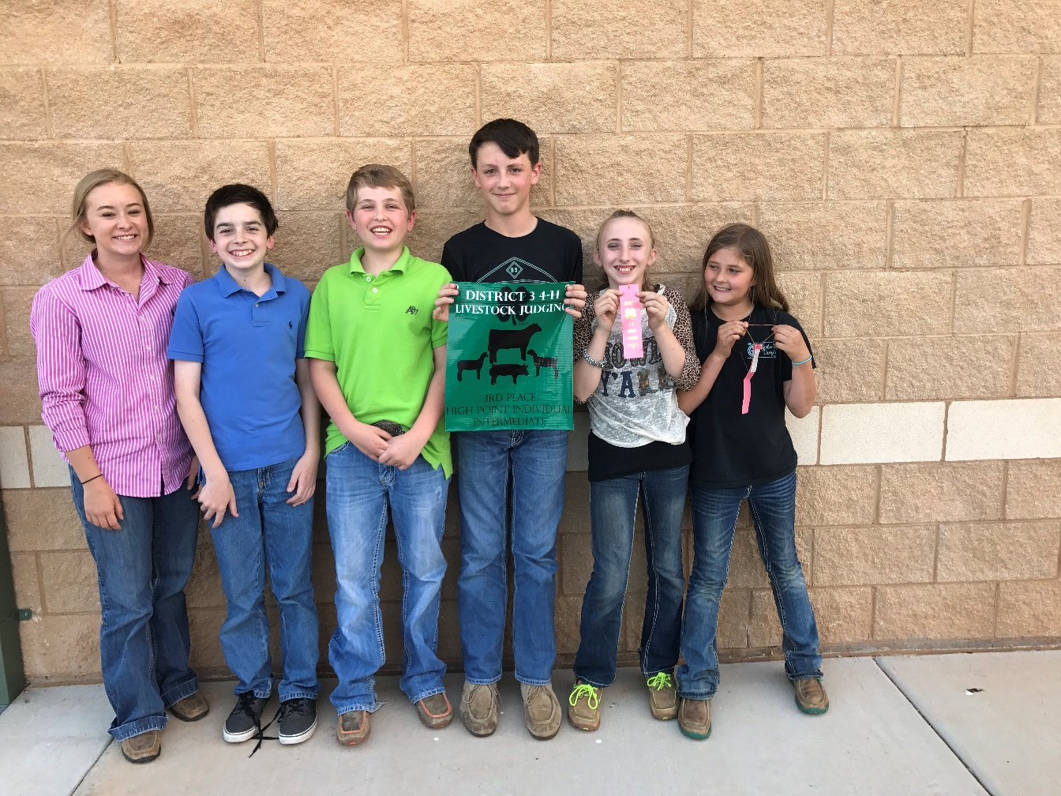

Dickens County SR. 4-H Meeting:

**DICKENS COUTY 4-H NEWSLETTER**



The SR. 4-H Meeting was held on April 30th and this meeting was focused on officer elections for the 2017-2018 year. The following are the officers for the SR. 4-H Club.

President: Shaylee Boger

Vice President: Jayden Duggan

Secretary: Kade Miller

Treasurer: Belle Smith

Reporter: Mackenzie Miller

Parliamentarian: Kollier Miller

Future events:

* May 20th- District Shotgun
* May 21st- Play Day
* June 6-9th Texas 4-H Round-Up
* June 11th – Play Day Awards
* June 21-23 District Horse Show – Vernon
* June 27-29th Teen Leader Lab
* July 16-19th Prime Time Camp I (5th- 8th grade)- Brownwood
* July 19-22nd Prime Time Camp II (2nd- 5th grade)- Brownwood
* July 22-29th State Horse Show- Abilene